BUGS

Personal Information

**Issue 1:**

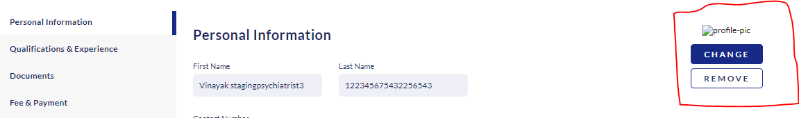

On Profile it was Accepting ZIP Files, Word Files, Note Files.

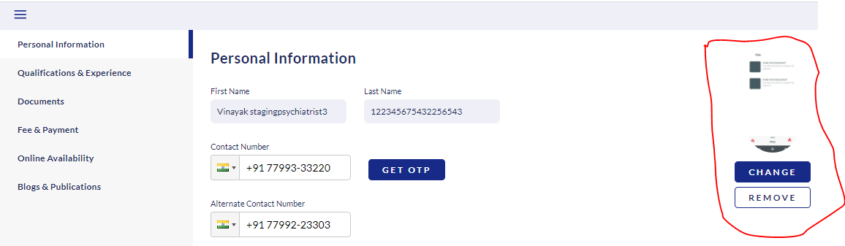

It Was Not Displaying the Pic Uploaded Completely in Square Shape.

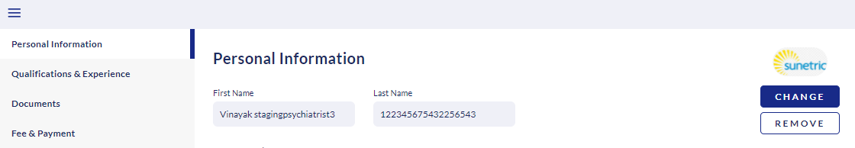

It Was Not Displaying the Pic Uploaded Completely in Square Shape.

**Issue2:**

**Validation Time Of The OTP Is Need To Be Mentioned On Message.**

Use OTP 7577 for mobile number verification. Welcome to InnerHour

**Issue 3:**

**OTP Message Received To Mobile**: Use OTP 7577 for mobile number verification. Welcome to InnerHour

**It Should Be** : Welcome to InnerHour. Use OTP 7577 for mobile number verification.

**Issue 4:**

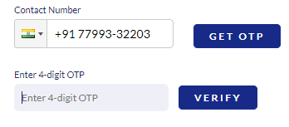

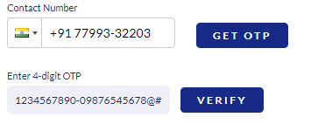

As It Mention Enter 4-Digit OTP, But It was Able to enter More than 4 Digits (Charcters, Digits,Symbols)

**Issue 5:**

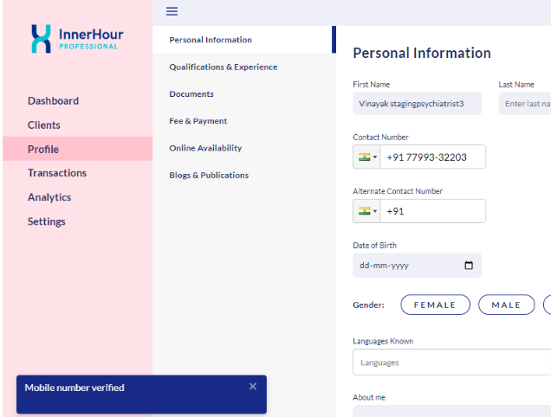

After 1 Minute Also OTP is Getting Validation.

**Issue 6:**

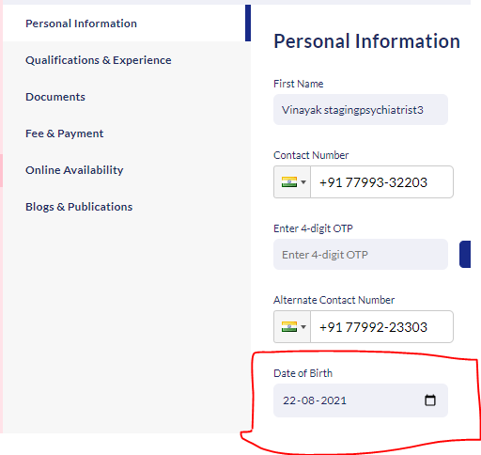

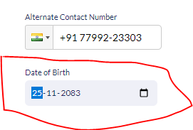

Accepting Future Date Of Birth. It Should Not Accept.

**Issue 7:**

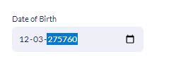

YYYY Is Able to enter More than 4 Digits.

**Issue 8:**

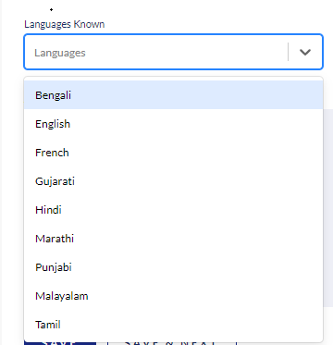

Almost All Languages (East, West, North, South) In India, Except Telugu Language From South.

**Issue 9**

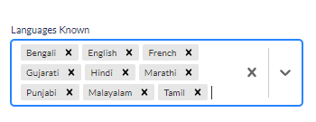

The Order Of the Selected Language is Missing (It Was Not Accepting FIFO/FILO/ Or other)

It was displaying Randomly.

Qualifications & Experience.

**Issue 1**

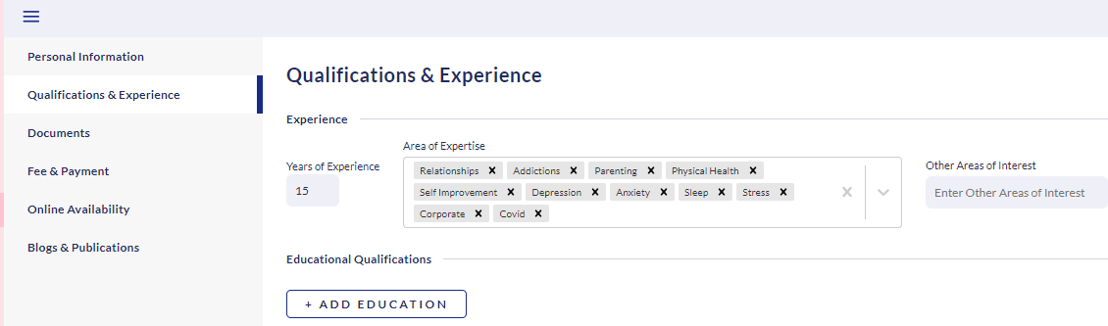

**Selection Of Order** On **Area Of Expertise** is Missing (Like FIFO or LIFO or ??)

**Issue 2:**

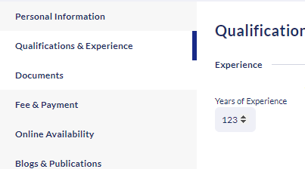

What Is The Limit of Years Of Experience, It Was Accepting More than 3 Digits ( 7799223303 Digits).

**Issue 3:**

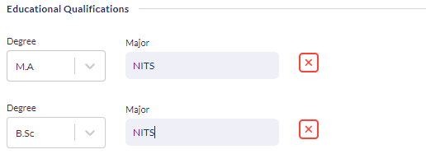

What Major Stands??Is It Marks or Pass %

**Issue 4:**



There Is No Save Option After Entering Education Details.(SAVE Button Should Be Present)

**Issue 5:**

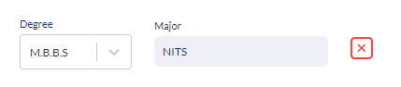

After Entering Education ,There Is No Successful Message.

**Issue6:**



While Deleting Educations Details, Their is no Warning/Popup Message.

**Issue 7:**

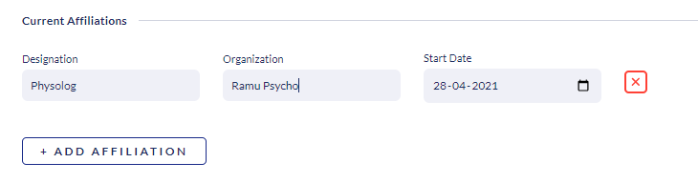

There Is No SAVE option, to SAVE, It was default getting save once we click on **ADD AFFILIATIONS.**

**Issue 8:**

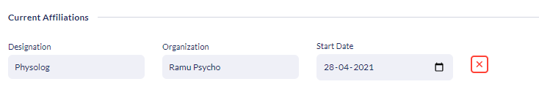

While Deleting **CURRENT AFFILIATIONS**, Their is no **Warning/Popup Message.**

**Issue 9:**

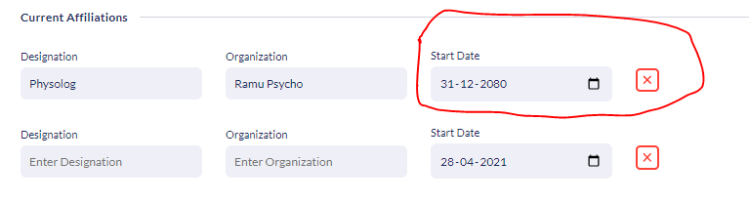

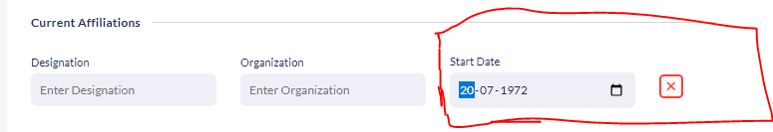

ForCURRENT AFFILIATIONS, It Was Accepting Past & Future Date.

**Issue 10:**

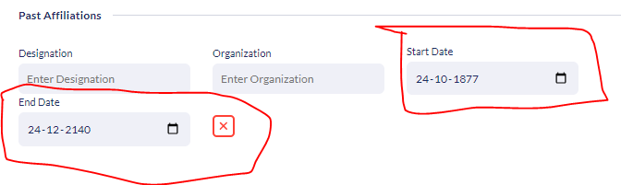

For **PAST AFFILIATIONS**, It Was Accepting Past & Future Date.

**DOCUMENTS**

**Issue 1**

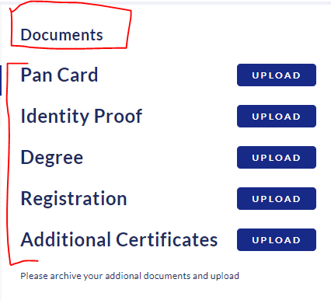

The Font Size Of the **DOCUMENTS Is Small** & Other File Names **(PAN CARD, Identity Prood, Degree, Registration, Additional Certificates) Font Size Is Large.**

**Issue2:**

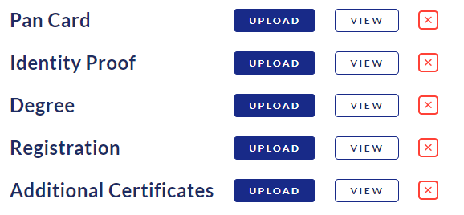

After Uploading File, User Receives Successful Message.

But Also it was Displays **UPLOAD Button,(It should show UPLOADED)**

**Issue 3:**

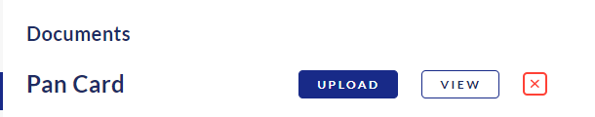

While Deleting File also there is no **POPUP /Warning**.

**Fee & Payments**

**Issue 1:**

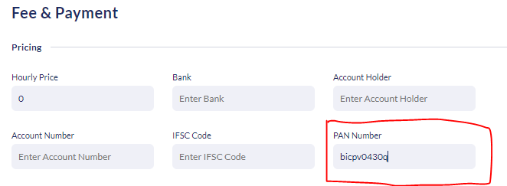

Pan Card Number is Accepting As Small Letters(Should Not Accept), But Comes to Other Sites It Will Accept Default as CAPITAL Letters

**Issue 2:**

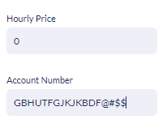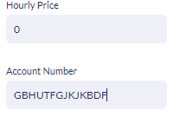

A/c Is Accepting Alphabet Letters & Special Char (It Should Not Accept)

**Issue3:**

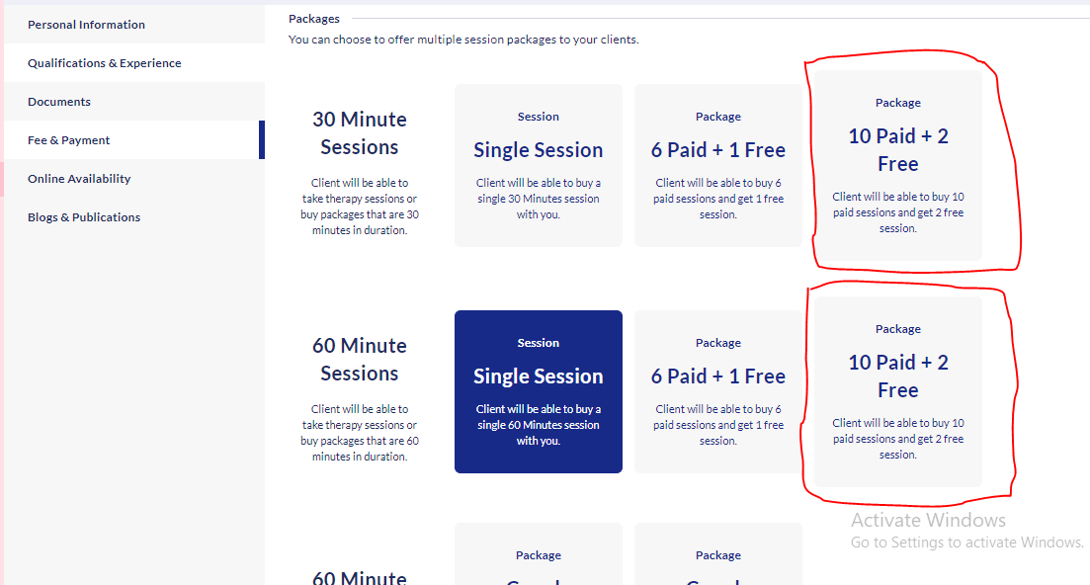

The Size Of The Highlighted Package BOX IS Not same As other Packages.

**Issue 4:**

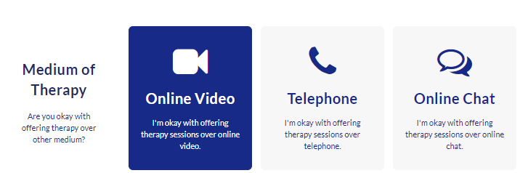

Unable to Deselect ONLINE VIDEO

Online Availability

**Issue1:**

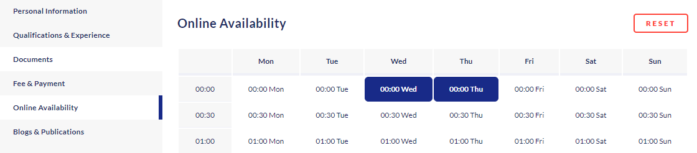

The Functionality Of The Selecting Slot Button & Reset Button Should Be SAME.

**BLOGS & pUBLICATIONS**

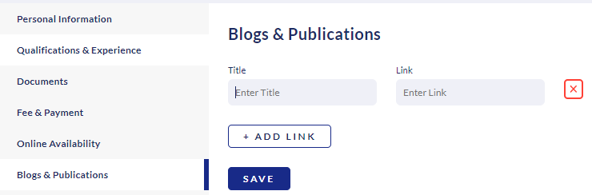

While Deleting A Popup/ Warning Message Should Be Display